

**WINTER – SEMESTER**

**Course Code:** MCSE505L

**Course-Title:** – Computer Network

**DIGITAL ASSIGNMENT – 1**

**(LAB) Slot-** L35+L36

**Faculty:** - SRIMATHI C (SCOPE) **Name:** Nidhi Singh

**Reg. No:** 22MAI0015

**Question 1:- Create simple network in mininet.**

**Answer :-**

**Test default network :-**

In this example, we are creating a network with one switch and two hosts using the sudo mn.

here's a simple example of how to create a network in Mininet. In the code bellow, ping command is used to connect h1 and h2 nodes together.

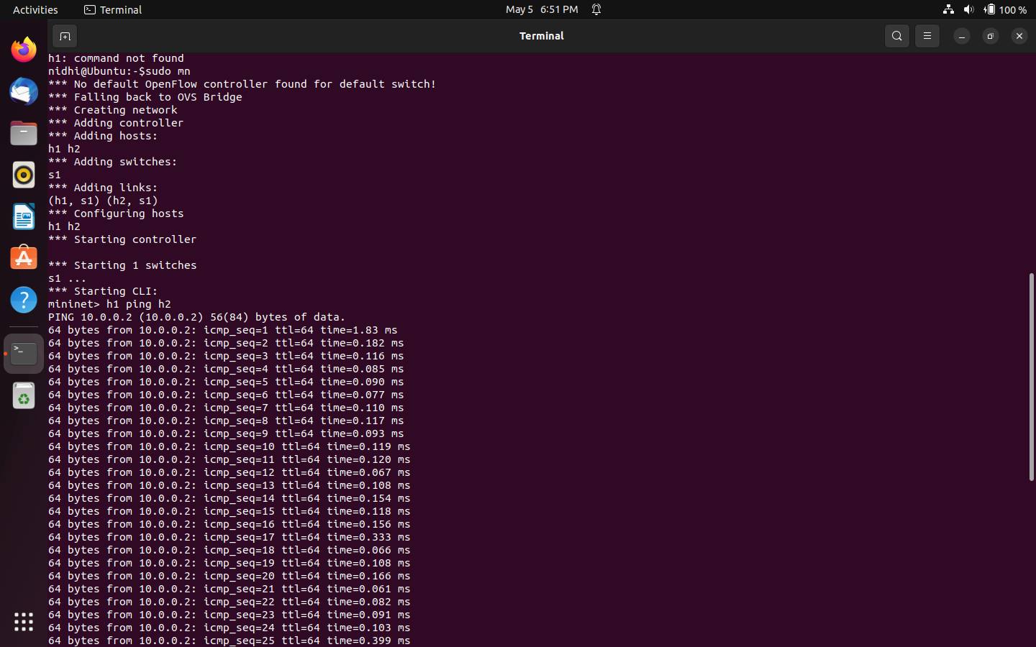

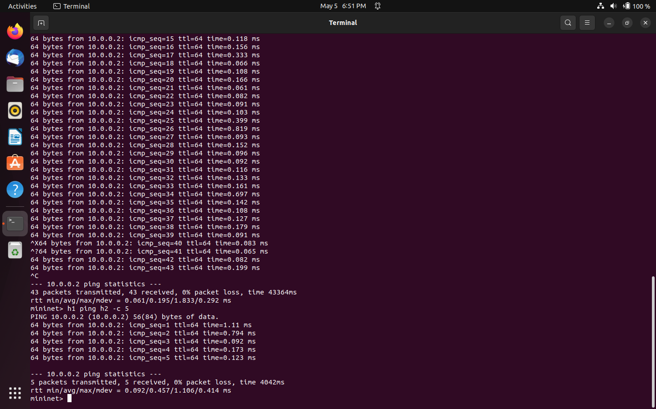

In the code above, we transfer 5 packets from node h1 to node h2 using command h1 ping h2 –c 5 .

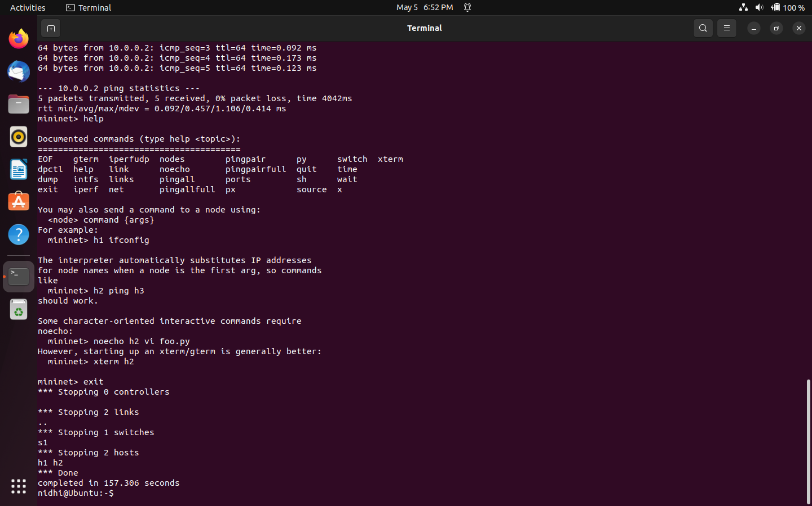

In the above code, help command is used to know about command documented.

**Creation of custom simple network using python :**

In Mininet, you can create a simple client-server network by defining a topology with multiple hosts and using the Mininet API to run a server process on one host and a client process on another host. Here's an example of how to do this:

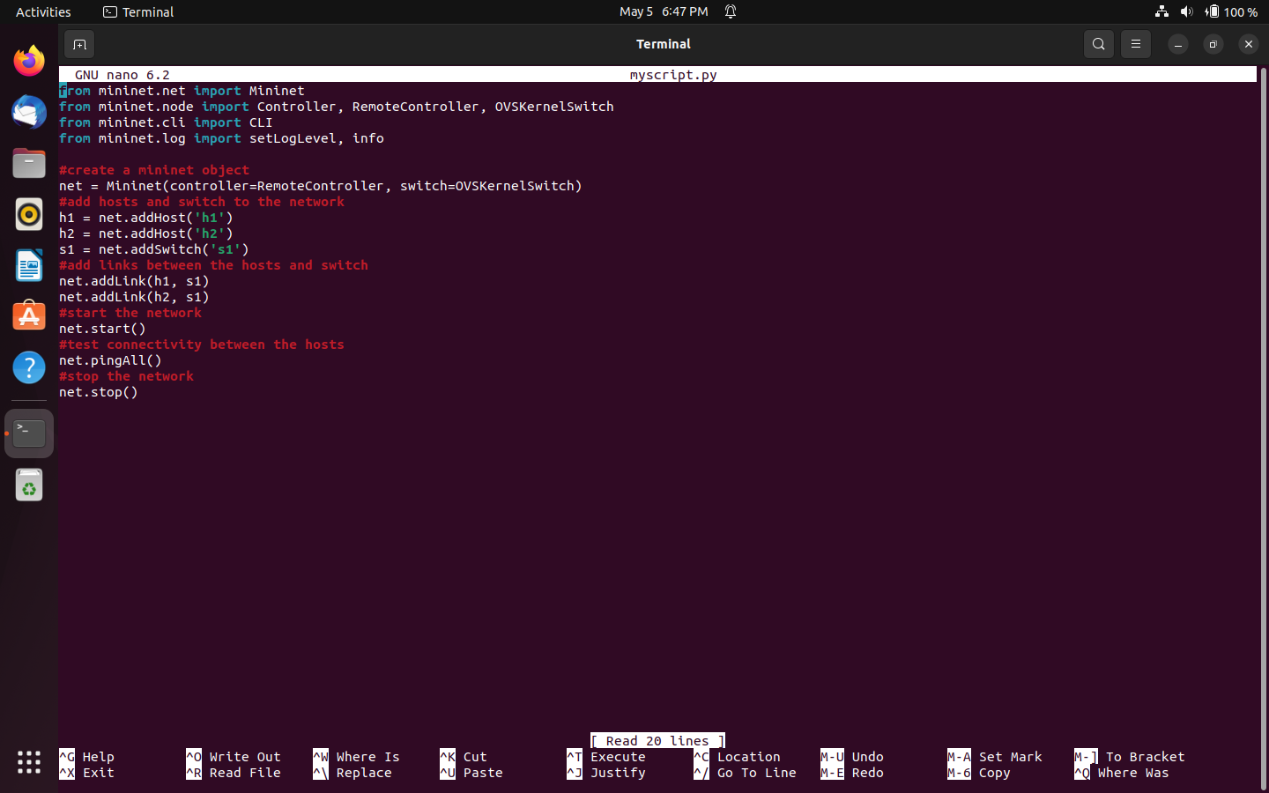

**Tree Topology Creation using Mininet:**

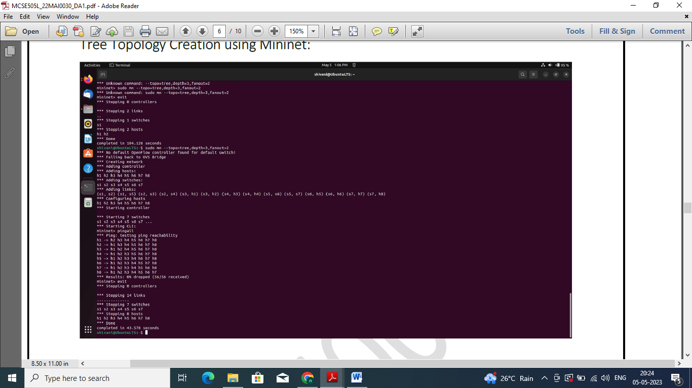

**Transfer of data between client and server :-**

When you run this code, you should see two xterm windows open up, one for each host in the network. The client process running on host h2 should download the index.html file from the server process running on host h1, demonstrating a simple client-server interaction.

Here is the screenshot of the process to transfer of data between client(Node :h1) and server(Node:h2).

In Mininet, you can use the xterm command to open a terminal window for each host in your network. This can be useful for interacting with the command line of individual hosts and running commands and programs within their respective namespaces.

Here's an example of how to use xterm in Mininet:

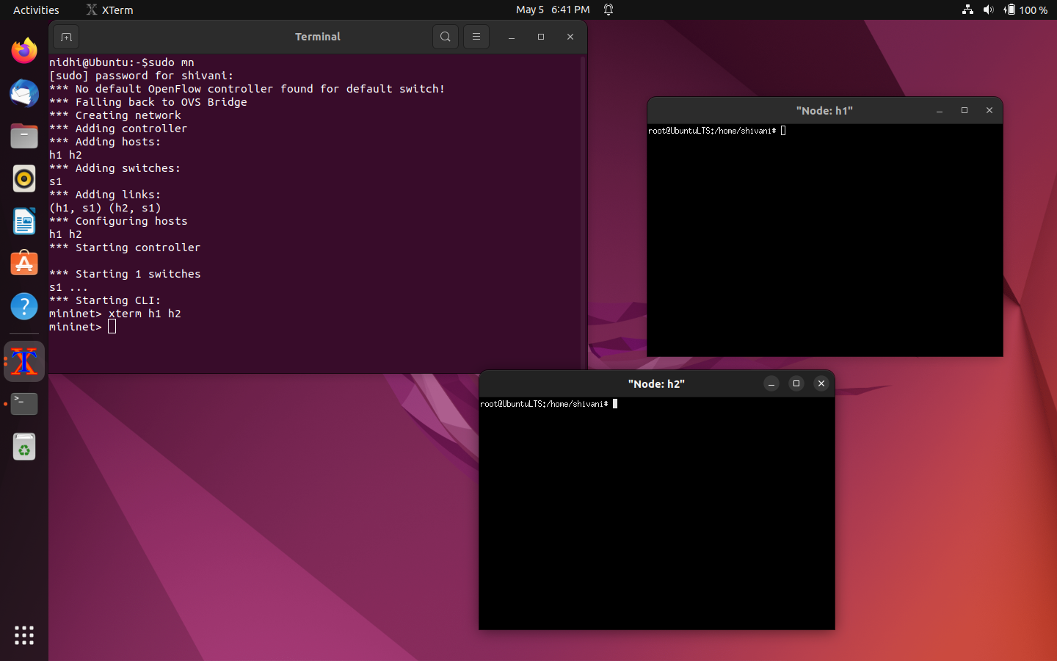

Next, we start a simple HTTP server on host h1 by running the command python –m http.server 9000. This will start a web server listening on port 9000, allowing us to serve static files over HTTP.

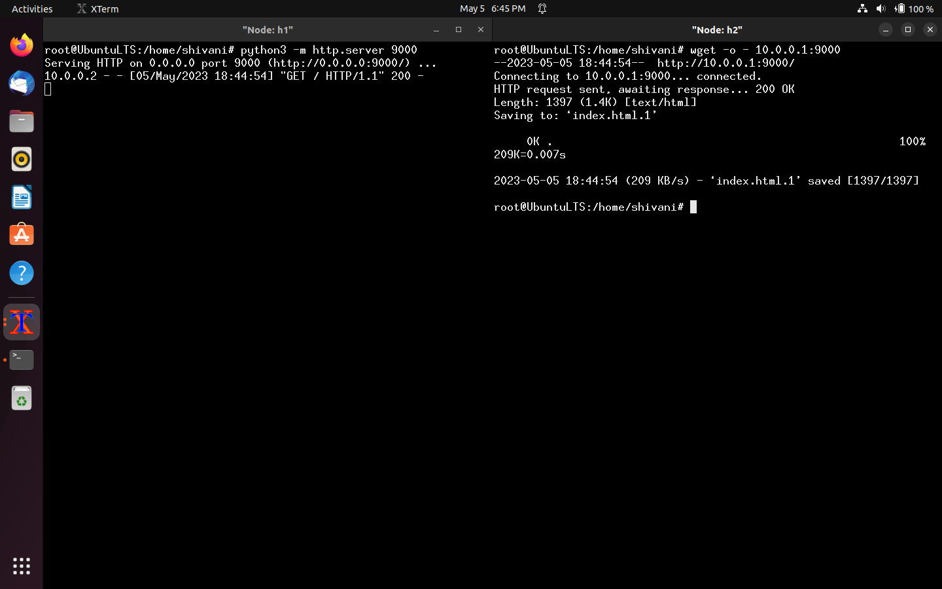

Next, we start a simple HTTP server on host h1 by running the command python –m http.server 9000. This will start a web server listening on port 9000, allowing us to serve static files over HTTP.

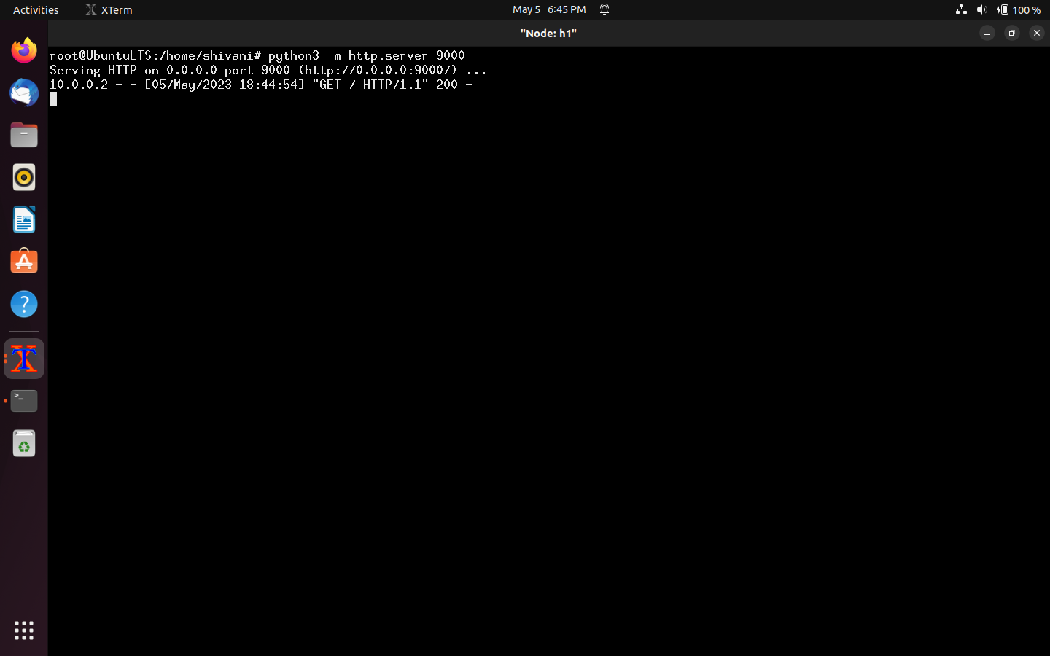

We then send a request from host h2 to the server on host h1 using the wget command, which downloads the contents of a URL to a file. In this case, we use the wget command to download the index.html.1 file from the server running on host h1.

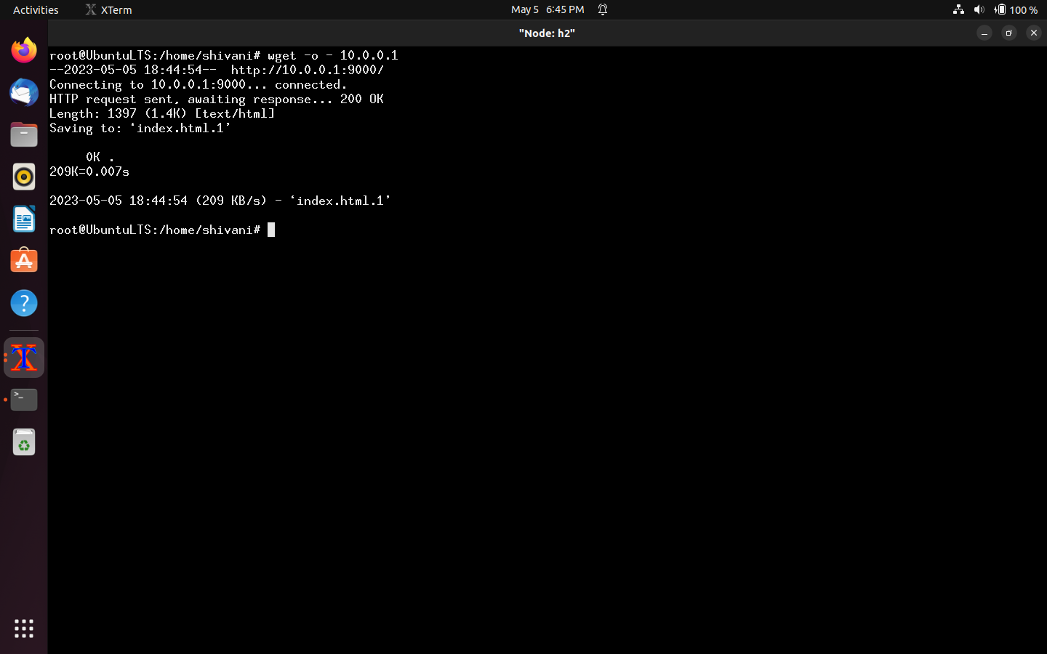

In Mininet, you can use the xterm command to open a terminal window for each host in your network. This can be useful for interacting with the command line of individual hosts and running commands and programs within their respective namespaces.

Here's an example of how to use xterm in Mininet:

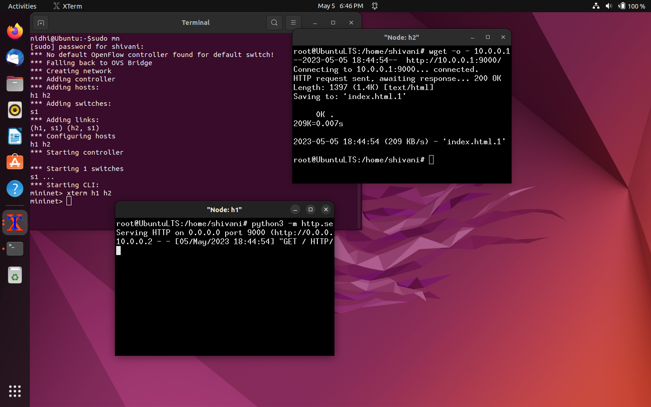

pingall is a command in Mininet that allows you to test the connectivity between all hosts in your network. When you run the pingall command, Mininet sends ICMP echo request packets from each host to every other host in the network, and reports whether each packet was successfully received or not.

**Here's an example of how to use pingall in Mininet:**

In Mininet, you can use the xterm command to open a terminal window for specific hosts in your network. This can be useful for interacting with the command line of individual hosts and running commands and programs within their respective namespaces.

To open xterm windows for hosts h1 and h2, you can run the following commands:Bottom of Form

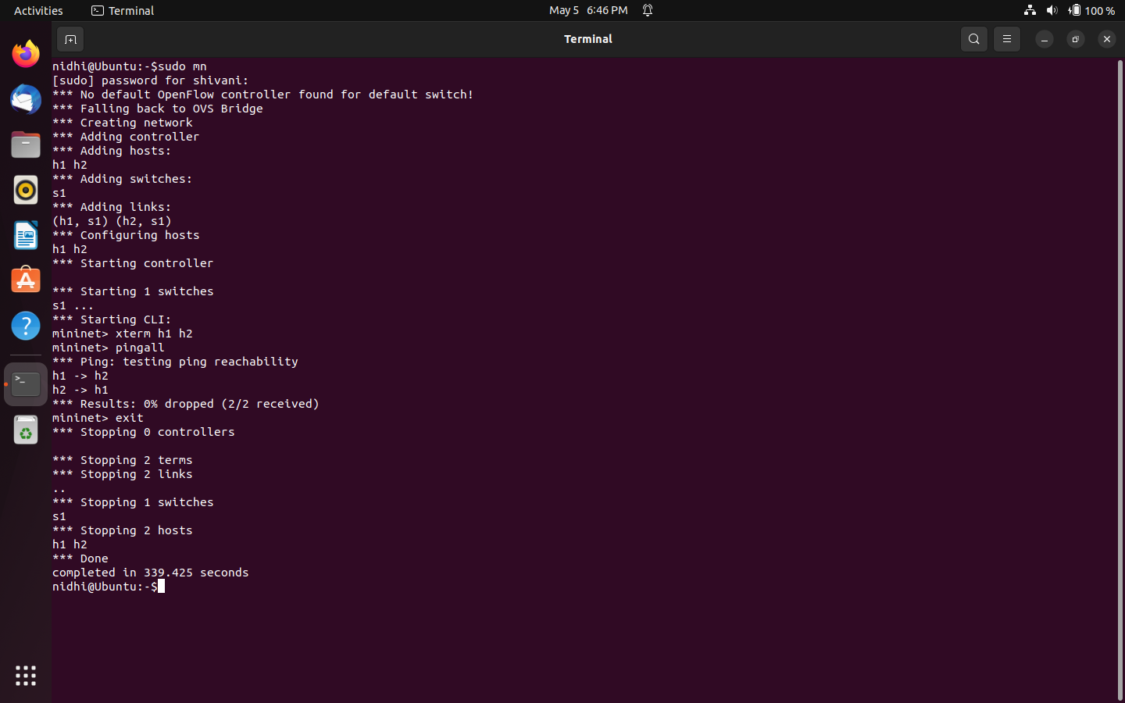

Finally, we open an xterm window for each host in the network, open the Mininet CLI, and stop the network when the CLI is exited.

